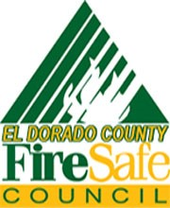
EL DORADO COUNTY FIRE SAFE COUNCIL
www.edcfiresafe.org (530) 647-1700
Community Green Waste Dumpster Program Application

Name of Community: ________________________________________

Community Dumpster Monitor (Primary)
Name: _______________________________________________
Address; _____________________________________________
Phone: ______________________ email: ___________________

Community Dumpster Monitor (Secondary)
Name: ________________________________________________
Address: ______________________________________________
Phone: ______________________ email:____________________

Dates of Community Clean Up: From_____________ To: ___________
NOTE: 1. Attach a copy of proposed flyer or notice
2. Do not distribute until your project has been approved by EDCFSC

Location of Dumpsters:
(Note: Dumpsters cannot be placed on a public roadway)
Dumpster 1: ___________________________________________
Dumpster 2: ___________________________________________

By signing this agreement, you acknowledge you have read and understand the terms and conditions of this agreement and the specifications are hereby accepted.

Primary: ______________________ Secondary:______________________
Date Submitted: ___________________
Approved By EDCFSC Dumpster Program Manager: ___________________________
Date Approved:______________

