EL DORADO COUNTY ASSOCIATE FIRE SAFE COUNCILS
*Spotlight Report 2025*
The following report Spotlights the hard work and great accomplishments the individual Associate Fire Safe Councils are proudly sharing with all of us…….
AUBURN LAKE TRAILS FIRE SAFE COUNCIL
Established in 2005 and a 501(c)(3) non-profit corporation
We are a Firewise USA® Community since 2005 (the longest active streak in California)
We are most proud to share these 2025 accomplishments:
- Awarded a $1.35M grant from CAL FIRE for the development of a Shaded Fuel Break (SFB) along the northern boundary of Auburn Lake Trails (ALT), bordering ASRA.

- Awarded and executed a $100k grant from PG&E for the development of a group of SFBs within ALT.

- Worked with the ALT Property Owners Association (POA) in the evaluation of all 1104 private owner lots within ALT for compliance with Defensible Space requirements.

- Worked with the POA in the execution of 592 complementary chipping operations for ALT residents.

- Provided two community green-waste dumpster days, used by 87 residents.

AUKUM FAIRPLAY FIRE SAFE COUNCIL

Established in 2019, is a Firewise Community
In 2025, outreach was identified as the number one priority for this board. Increasing visibility, engaging the younger generation, and strengthening community participation were central goals. To achieve this, AFFSC participated in two key events:
1. National Night Out’s objective was to engage youth & families in wildfire education.
Location: Local school.
Activities:
- Fire education games designed for students.
- Informational outreach on AFFSC’s mission.
- Bake sale to draw interest and encourage interaction.
Impact: Successfully increased awareness among younger residents while providing approachable, family-friendly fire safety education.
2. Zin Fest
Objective: Build partnerships with local wineries and promote Firewise benefits.
Highlights:
- Strong enrollment in the Defensible Space Program.
- Increased knowledge of AFFSC and Firewise discounts.
- Successful Silent Auction and Bake Sale: every item sold, all baked goods sold out, exceeded fundraising goals.
Impact: Established this as an annual event due to its overwhelming success in both outreach and fundraising. Looking ahead AFFSC will continue to prioritize education and outreach, ensuring residents of all ages understand the importance of our mission.

CAMINO FIRE SAFE COUNCIL

Established in 2022, is a Firewise Community
#1 CFSC continued to expand our fuels reduction activities, which included collaborating with Growlersburg crews to clear a portion of the El Dorado Trail and coordinating "Community Cleanups" in multiple neighborhoods. CFSC leveraged our FY25 Title III funds to facilitate nine clean-up weeks, during which a total of approximately 32 households worked together to reduce the fire fuels on their individual properties and shared roadways. CFSC continued our ongoing, positive collaboration with El Dorado Disposal (EDD), which provides a 25% discount on their green yard debris bins. Together, CFSC, EDD, and local Camino residents removed 29 tons of hazardous fire fuels from our community.
#2 CFSC also bolstered our Outreach and Education activities by expanding our social media presence; in 2025, CFSC added an Instagram account to our existing (and thriving) Facebook and Nextdoor Neighbor pages. We also conducted Home Assessments with our newly trained Assessors, made and sold reflective residential address signs, and hosted our first CFSC Rummage Sale Fundraiser, a successful community event that we plan to repeat annually.

COLOMA LOTUS FIRE SAFE COUNCIL

Year of Establishment: 2015(?)
Coloma Lotus FSC has 5 Firewise: Coloma-Lotus, Thompson Hill, Woodridge, Luneman North, Gold Hill
Accomplishments:
• Rapid growth has resulted in the creation of five Firewise Communities as well as a newly structured board with a board member representing each neighborhood or community in our fire safe council.
• We did three green waste days (our first ever) in the communities of Riverwood, Thompson Hill and Arrowbee.

DIAMOND SPRINGS FIRE SAFE COUNCIL

Established in 2021 is also a Firewise Community.
Our current big project is working with the El Dorado Sheriff’s Office to schedule and conduct a neighborhood fire drill within our Fire Safe Boundary area in 2026. Other DSFSC efforts are to continue completing residential defensible space and home hardening activities within our neighborhoods to help us be safer from wildfire and remain a certified Firewise Community.
EL DORADO HILLS SOUTH FIRE SAFE COUNCIL

EDHSFSC,
• Year of Establishment- January 2025 as Heritage El Dorado Hills Fire Safe Council changed to EDHSFSC in June 2025
• 2 Firewise Communities within EDHSFSC: Heritage EDH Firewise Community & Four Seasons EDH Firewise Community
In 2025 we are most proud to share:
#1 Rebranding to EDHSFSC, which is made up of three separate communities totaling 1923 homes.
#2 Very strong community support for the Fire Safe Council, with 140+ attendees at the June 2025 community meeting
COOL PILOT HILL FIRE SAFE COUNCIL

Reorganized June 2025 with a Firewise Community in Cool.
We are most proud to share:
1: We have held a monthly board meeting each month.
2: On October 25th, the CPH FSC held a Fire Fair at the Pilot Hill Grange in partnership with the Cool Firewise Community, featuring a number of speakers to inform area residents about how the EDC OES does evacuations, insurance issues and anticipated changes that we may see in the next year in the industry, the importance of having go-bags prepared and what to consider in making one, and the purpose and function of the EDC OWPR.

FORT JIM FIRE SAFE COUNCIL

Established in 2023-
Top 2025 Accomplishments:
- Conducted successful quarterly public meetings, consistently drawing strong, growing attendance to discuss critical firesafe initiatives and build community resilience.
- Led two highly effective Green Waste days, allowing residents to safely dispose of flammable vegetation and significantly reducing fuel loads in the community.
- Deployed reflective street signs throughout the community, a popular initiative that improves emergency responder navigation and enhances safety, demonstrating the council's positive impact.
- Completed numerous fire-risk assessments, using expert assessors to provide one-on-one education to homeowners on creating defensible space and fire-hardening their properties.

GALLAGHER ROAD FIRE SAFE COUNCIL

Established in 2019, is a Firewise Community
Reducing GRLA's Wildfire Risks: GRLA has done great work to reduce our home and community wildfire risk levels. In our October Fire Safe Firewise Council Meeting, we noted almost every homeowner has done at least some Home Hardening and Defensible Space work in 2025. Our Firewise Risk Assessment survey ed 31 tasks, like the 5-foot clearance, vents covered, eaves enclosed, etc. We found that 18 of the tasks (58%) were done by over 94% of the homeowners who reported. GRLA had over 2,847 hours and $34,835 of work done to reduce our wildfire risks in 2025. This included $3,000 of Title III grant funds. Great job by all!!
Roadside Clearing: In our June HOA Meeting GRLA discussed the County Ordinance related to roadside clearances and gate access for emergency responders. Both these are critical in a wildfire, emergency and evacuation situation. Roadside clearances reduce flames and smoke along our roads. This is very important so people can evacuate and emergency responders and equipment can get in to our community. 84% of our properties have done some work to improve roadside clearances. In some cases, our community work crews helped where needed. Also, work done under the El Dorado County Fire Safe Council Title III grant helped achieve our goals. Great job by all!!

GEORGETOWN DIVIDE FIRE SAFE COUNCIL

#1 Held our first annual Divide Wildfire Expo, an all-day information and education event in Georgetown in March 2025. Approximately 50 community members attended. Project was a collaboration with Garden Valley Fire Department.
#2 Organized information booths at multiple events on the Divide, including:
- the Garden Valley Farmers Market (once a month during the market season - total attendance over 5 months = 1000 people)
- Founders Day (total attendance estimate: 500 people)
- Marshall Wellness Fair - (total attendance estimate: 150 people)
- Golden Sierra High School football game (attendance estimate: 200 people)
- Georgetown Divide Public Utility District Fire Forum (attendance estimate: 30 people)
#3 Eight members of our fire safe council were trained as volunteer defensible space/home hardening assessors, resulting in 20 home assessments in 2025 to date.
#4 Completed a 53-acre roadside fuel reduction project on Marshall Road, between Georgetown and Garden Valley, a major evacuation route.
#5 Conducting a 2000-acre fuel reduction project in Kelsey, with 700 acres completed to date.
GOLD HILL ESTATES FIRE SAFE COUNCIL

No Spotlight Report this year
GOLD RIDGE FOREST FIRE SAFE COUNCIL

Gold Ridge Forest Fire Safe Council is a Firewise Community.
Gold Ridge Forest Fire Safe Council, GRFFSC, held their annual Green Waste dumpster day offering a free fuels reduction opportunity to our community residents. Gold Ridge Forest FSC has cleared all our greenbelts; some have been cleared twice. Gold Ridge Forest FSC continues to encourage homeowners to create defensible space around their homes. We promote the use of the EDCFSC’s Chipping, Defensible Space and Hazardous Tree programs, and encourage homeowners to harden their homes against wildfire.
The Gold Ridge Forest Fire Safe Council and residents work hard to keep our community safer from wildfires.
GREATER CAMERON PARK FIRE SAFE COUNCIL

No Spotlight Report this year

GREENSTONE COUNTRY FIRE SAFE COUNCIL

Established in May 2022. Firewise USA certification was granted in May 2023.
Accomplishments since inception:
- Completed Community Wildfire Protection Plan.
- Completed a Risk Assessment Survey to all members of the community - 56 percent response to the survey was completed in January 2023.
- Kick off Town Hall Meeting (held on February 1, 2023) - education on home hardening, state and county laws regulations regarding wildfire preparation and defensible space.
- HOA monthly newsletters.
- HOA and GCFSC Monthly Meetings
- Three GCFSC board members completed two-day defensible space/home hardening training. 53 structures have been assessed.

GRIZZLY FLATS FIRE SAFE COUNCIL

Established in 2004, has been a Firewise Community since 2007
Our two greatest accomplishments in 2025 are the following:
- On June 28, 2025, we held our annual Firewise Day/Fundraiser. It was held in partnership with Grizzly Flats Burger Nights. Approximately ninety community members attended. The Grizzly Flats FSC had three tables with public information available, and several allied agencies also had their information tables set up. The event was a great success!

- On September 27, 2025, the Grizzly Flats Fire Safe Council, in partnership with Leoni Meadows, conducted our annual Community Cleanup. Two 40 cubic yard dumpsters and two El Dorado Disposal compactor trucks (24 and 29 cubic yards each) were filled with green waste and assorted trash from the community.

MOSQUITO FIRE SAFE COUNCIL

No Spotlight Report this year
LOGTOWN FIRE SAFE COUNCIL

Established in 2006 after a fire on Hwy 49 burned two homes in our area. We are one of the original El Dorado County Firewise communities.
Our two top accomplishments for 2025 were:
1. Community Green Waste cleanup and wildfire awareness day May 3, 2025. We had two 30-yard dumpsters that were completely filled. There was a chipper on site, and one dumpster was filled with chipped material causing it to exceed the allowable weight. The event was well attended and resulted in a safer, more prepared community.
2. The annual Hot Dog Social was held on October 11th at Station 44. It was a very successful event enjoyed by many community members. We had a lot of fun playing and learning from Logtown Jeopardy where the categories were: Home Hardening, Defensible Space, Logtown History, The Bonanza Fire and Notification. Wildfire preparedness material was also distributed.
LAKEHILLS FIRE SAFE COUNCIL

Established in 2012 and expanded in 2013.
Lakehills FSC has 2 individual Firewise Communities
For 2025, we are proud to share the following accomplishments:
- We expanded our fire safe council boundary to include all developments in the El Dorado Hills north peninsula area. We now comprise 12 residential developments (including 2 Firewise communities), 1 commercial development, and 2 schools.

- In association with the El Dorado County Sheriff's Office and Office of Emergency Services, we conducted an evacuation exercise that included electronic notification to the entire council area and door-to-door evacuation of one specific development. Additionally, we set plans with the local fire district to conduct defensible space reviews for all residences within the council boundary.

OMO RANCH FIRE SAFE COUNCIL

Omo Ranch Fire Safe Council, which is also a Firewise Community, is excited to share two of our accomplishments for the year!
*One of our recent projects was installing 8 water tanks, at two separate locations, totaling 40,000 gallons. We accomplished this in partnership with our local fire protection district.
*We also were part of a multi-council grant that made up the South County Fuels Reduction Project sponsored by CalFire. We were able to accomplish this by the strong partnership formed with local fire safe councils which have created a South County Fire Defense Coalition to support one another through an education and outreach program at local events.

OAK HILL AREA FIRE SAFE COUNCIL

Est. 2019, and a Firewise Community since 2020.
Most proud achievements 2025:
- Fourth annual Community Day, a fun day in which we celebrate all the defensible space and home hardening work people have done over the last year. We provide free music, food, information tables, kids games and people write their hours/$ spent on large sheets that everyone can see and be inspired by.
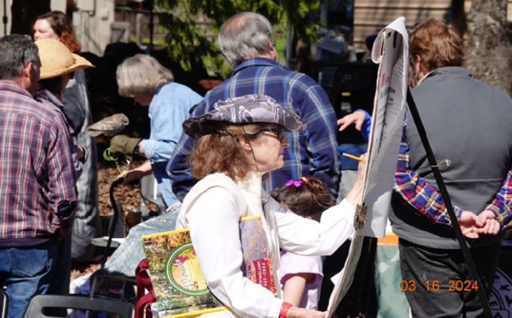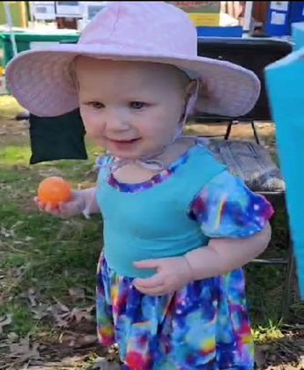
- Extensive clearing of hazardous fuels along several roads really got going, as did shaded fuel breaks away from roads. This was by working with the EDC RCD and 5 other South County fire safe councils. This also set us up well to pursue a second joint CAL FIRE grant proposal in 2025.
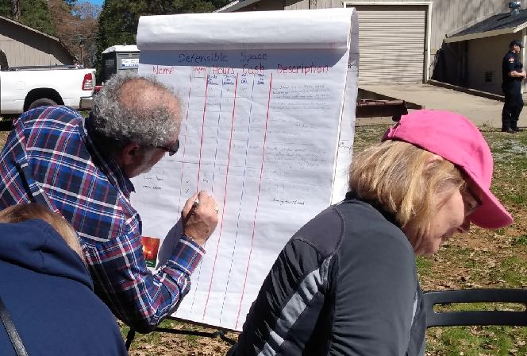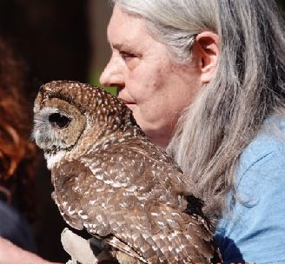
++ Oak Hill FSC sent two before and after pictures of defensible space work. Unfortunately, we were not able to include the pictures in this year’s report.

PATTERSON RANCH FIRE SAFE COUNCIL

No Spotlight Report this year
PLACERVILLE FIRE SAFE COUNCIL

Established has 4 Firewise communities
#1 Placerville FSC is proudest of our annual Spring event promoting Wildfire Awareness and Preparation. This event draws people from all over the County and includes multi agency participation. Placerville Rotary even helps to make this a very successful event.
#2 The Placerville Fire Safe Council not only includes the LRA of the City of Placerville but the surrounding Placerville SRA area, making us very proud in the fact that ALL of Placerville Fire Safe Council is Firewise. We have 4 Firewise communities within the Placerville FSC boundary area.

RANCHO DEL SOL FIRE SAFE COUNCIL

Established 2018 and is also a Firewise Community
This 2025 year we are most proud to share:
1.) We organized a Community Green Waste event in May and filled four 20-yard dumpsters. Residents were encouraged to fill green waste bags at their residence and volunteers picked up the bags for those residents that were not able to transport them to the dumpster area. This resulted in an additional 102 thirty-gallon bags being collected.
2.) We continued our resident education & outreach efforts including maintaining our information bulletin board in the community mailroom, monthly resident emails with relevant topics, maintained the RDSFSC website and completing six Home Hardening & Defensible Space assessments for our residents.
#1 Placerville FSC is proudest of our annual Spring event promoting Wildfire Awareness and Preparation. This event draws people from all over the County and includes multi agency participation. Placerville Rotary even helps to make this a very successful event.
#2 The Placerville Fire Safe Council not only includes the LRA of the City of Placerville but the surrounding Placerville SRA area, making us very proud in the fact that ALL of Placerville Fire Safe Council is Firewise. We have 4 Firewise communities within the Placerville FSC boundary area.

ROYAL EQUESTRIAN ESTATES FIRE SAFE COUNCIL

No Spotlight Report this year
RESCUE FIRE SAFE COUNCIL

No Spotlight Report this year
SAND RIDGE FIRE SAFE COUNCIL

Reformed in 2022 and became a Fire Wise community the same year.
We are most proud to share that in 2025 our community has
1) 3 trained assessors who continue to connect with and educate residents about home hardening and defensible space best practices.
2) Strengthened its connections with neighboring AFSCs in South County to form a really strong regional presence.

SERRANO FIRE SAFE COUNCIL

Established 2024, has 3 Firewise Communities within its boundaries
#1 Firewise: To earn Firewise USA® recognition, we organized Serrano’s 4,700 homes into three separate communities—and successfully achieved certifications for all three. This accomplishment followed a comprehensive community risk assessment, the development of an action plan, and detailed documentation of the time and resources homeowners invest in maintaining defensible space around their properties and adjacent open space areas. The Firewise program is a natural fit for Serrano. It recognizes community collaboration and tangible progress in reducing wildfire risk, while also helping homeowners qualify for potential insurance discounts.
#2 Community Outreach: In just 16 months, the Serrano Fire Safe Council ignited a wave of wildfire awareness and action. We launched a full-featured website, produced six engaging videos, sent several educational emails to over 3,000 homeowners, and participated in National Night Out. Our social media posts can reach more than 7,000 Serrano residents. Five dedicated Council members trained with CAL FIRE and the Fire Department—then completed over 30 home assessments in only two months and developed a trusted list of qualified contractors to help residents harden their homes. Serrano is turning awareness into real, measurable wildfire safety results.

SIERRA SPRINGS REGIONAL FIRE SAFE COUNCIL

No Spotlight Report this year

STRAWBERRY FIRE SAFE COUNCIL

Strawberry Fire Safe Council is a Firewise Community, established November 2021,
#1 Our Fire Safe Council is creating community. Harlan from Sciot’s Camp shared the only reason he was inspired to become a Fire Wise community was due to work being done by the Strawberry FSC. We never know who we will inspire, impact and motivate. Relationships are being created as we are accomplishing our desired goals.
#2 This year SFSC proudly submitted its third Firewise Certification, ( 2023-2025.) Within the Firewise certification process residents are encouraged to self-assess their properties. This is based on a format that identifies areas of home hardening. Each year more than two-thirds of the community has complied with the self-assessment. In addition, year after year they have followed up in maintaining and improving the home hardening process.
We are very proud of the community’s collective willingness to organize, educate and facilitate themselves for the common good.

TEXAS HILL ESTATES FIRE SAFE COUNCIL

Established in 2019, is a Firewise Community
Our two main accomplishments were:
• Green Waste Day (Title III Grant) April 26, 2025. Residents filled 2 - 30-yard dumpsters. We also hired MAG Landscaping to chip brush piles for 9 homes.
• Community FSC Meeting regarding Evacuation. Speakers from EDSO and El Dorado County Fire Protection attended along with one of the newer fire engines for everyone to see. A lot of great questions were asked and answered regarding RAVE and evacuation protocol.

VOLCANOVILLE FIRE SAFE COUNCIL

No Spotlight Report this year

WRIGHTS LAKE/DARK LAKE FIRE SAFE COUNCIL

No Spotlight Report this year

