Request for Proposal: On Call Tree Crews - El Dorado County Hazard Trees

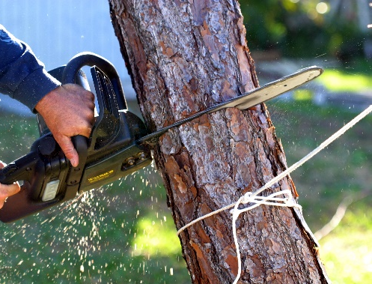

Mason, Bruce & Girard, Inc.
701 High Street, Suite 207
Auburn, CA 95603
530-745-9996
www.masonbruce.com

Introduction
On behalf of the El Dorado County Fire Safe Council (EDCFSC), Mason, Bruce, & Girard, Inc. (MB&G) is seeking proposals from qualified contractors to be On Call Tree Crews for the removal of hazard trees in El Dorado County, California. The successful applicants will be eligible to bid on future work packages associated with a large-scale hazard tree removal project (“the Project”). The purpose of this RFP is to obtain additional contractors to respond to higher than anticipated demand for the program.

Scope of Work
The EDCFSC has obtained grant funding from CALFIRE for a landowner cost-share program to remove hazard trees. Trees eligible for removal under this grant include those which are beetle-infested, dead, or dying, decaying and overhanging homes, and which could potentially fall on a primary residence, driveway, public roadway, or emergency fire escape route. This project will run through 2025 and will consist of between 15 and 20 bid packages. Bid packages will include approximately 20 different parcels in a geographically close area, each with generally between 1 to 10 Hazard Trees.
Of the respondents to this RFP, up to three companies will be added to our On Call list. These three companies will be eligible to bid on all future work packages associated with the Project. If a contractor is selected to be On Call, it is not a guarantee that any future work package will be awarded to that Contractor.

Contractor Responsibilities
The contractor will be expected to remove all trees contained in a bid award within 4 weeks of contract award. Exceptions will be made for weather-related delays. Trees must be cut to a 6-inch stump, measured on the uphill side, unless a landowner gives permission for a higher stump height. The contractor will not be required to remove cut trees but will be required to chip all material less than 8 inches in diameter and transport all material over 8 inches to designated location on the same property where the trees were cut. The contractor will be required to buck logs into firewood rounds at landowner request. Felled trees (bucked to any length) with signs of live larvae will be covered in plastic to limit the spread of beetle infestation. When feasible, the contractor will be required to move felled tree boles a minimum of 30 feet from any structure to maintain defensible space. Any exception must be approved by MB&G on a parcel-by-parcel basis.
On a case-by-case basis, the contractor may determine that a tree which has been identified for removal cannot be cut down safely. In this event, an MB&G Certified Arborist or Registered Professional Forester will assess the condition of the tree. If the MB&G staff member agrees with the contractor’s determination, the tree will be stricken from the work package.

Work Verification
After all identified hazard trees on a property have been cut down, the contractor will report this to MB&G. An MB&G Certified Arborist or Registered Professional Forester will visit the property within two weeks of the report to confirm that all work has been completed to specification. If specifications have not been met, the contractor will be required to return to the property and complete the missed work.

Damage to Property
If damage to landowner property results from contractor activities undertaken in the course of completing work for the Project, the contractor will be responsible for repairing that damage or replacing damaged property. This must occur within one month of the damage incident. The contractor shall bear all costs associated with repairing or replacing the damaged property. Examples of damage include, but are not limited to:
- Damage to structures or buildings on the property such as a fence, shed, or garage.
- Damage to pavement, sidewalks, or driveways caused by heavy equipment or falling tree limbs
- Damage to underground utilities such as gas or water lines
- Damage to landscaping or gardens
- Damage to neighboring properties such as a neighbor's fence or landscaping
- Damage to the surrounding soil or terrain, such as erosion or rutting
Once selected to be On Call, and prior to commencing work, Contractor shall provide MB&G with a Certificate of Insurance evidencing the required insurance coverages for general liability, property damage, automobile liability, and worker’s compensation insurance.

Safety Requirements
By submitting a response to this RFP, the contractor agrees to comply with all applicable Occupational Safety and Health Administration (OSHA) regulations and all applicable federal, state, and local laws and regulations related to tree removal. The following safety requirements must also be met:
- All workers must be trained and certified in the proper use of chainsaws and other tree removal equipment.
- Personal protective equipment (PPE), including hard hats, eye and ear protection, and chainsaw chaps, must be worn at all times while working on Hazard Trees.
- A qualified safety supervisor must be on-site at all times during tree removal operations.
- All equipment must be properly maintained and inspected regularly to ensure it is in good working condition.
- Work must be scheduled and conducted in a way that minimizes risk to workers, adjacent properties, and the public.
- Trees must be felled in a controlled manner, and workers must be positioned in a safe location during felling and removal operations.
- Hazard Trees that are located near power lines must be removed by qualified line clearance tree trimmers, in accordance with applicable regulations.
- Contractors must provide and maintain adequate traffic control devices, such as cones, signs, and barriers, in accordance with the California Manual on Uniform Traffic Control Devices (MUTCD).
- Contractors must coordinate owners/agencies responsible for public roads and obtain any necessary permits for road closures or lane closures.
Failure to comply with these safety requirements may result in removal from the On Call Tree Crew list and termination of any existing bid awards at MB&G or EDCFSC’s discretion.

Environmental Considerations
The contractor must not track vehicles and machinery into flagged equipment exclusion zones and must not broadcast chips or other debris into these zones. If violations of this policy are discovered, the contractor must correct them promptly. Any fines resulting from these violations are the sole responsibility of the contractor.

Landowner Communication
The contractor must communicate with landowners in a professional and courteous manner. The following landowner communication procedures must also be met:
- The contractor must provide landowners with at least 48 hours’ notice before arriving on their property to initiate tree removal operations.
- The contractor must coordinate with landowners to schedule work at a time that is convenient for the landowner and does not cause undue disruption or inconvenience.
- The contractor must provide clear and concise information to landowners about the scope of the work to be performed, the expected duration of the work, and any potential impacts on the landowner's property.
- The contractor must ensure that all workers and equipment remain on the property where work is being conducted and do not encroach onto neighboring properties without prior written authorization from the adjacent landowner.
- The contractor must maintain a clean and safe work area, free of debris and other hazards, and must take all necessary precautions to prevent damage to the landowner's property.

Structure and Process of Bid Packages
Detailed maps will be provided to contractors as part of the bid packages, and contractors will have two weeks before bids are due in which they can visit sites in the field. Bid packages will contain a full list of trees eligible for removal including the height, diameter, species, and whether or not that tree leans towards a target. Contractor will be required to submit a price matrix in the following format:
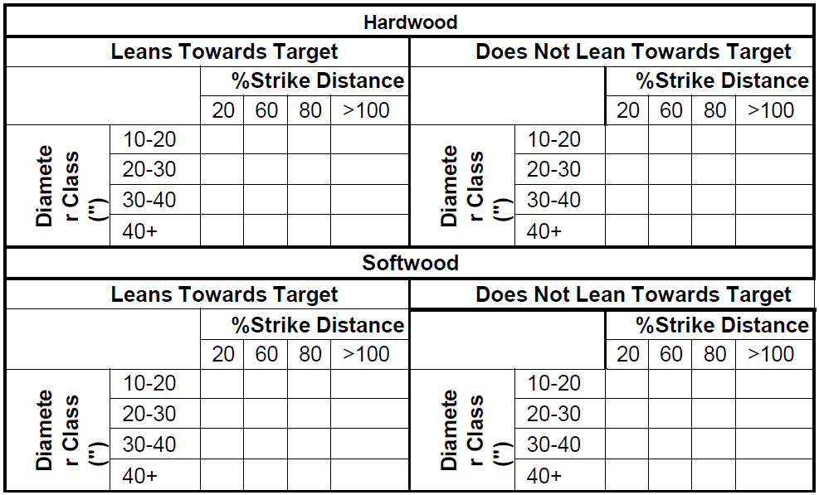
Once bids from all three On Call Tree Crews have been received, the bid award will be sent within one week to the contractor who has won that package. The bid award will include the list of trees that are to be removed by the contractor, which may be fewer trees than the initial bid package; under the terms of the CALFIRE grant, EDCFSC is limited to a total tree removal expenditure of $5,000 per property (including landowner contributions). Based on the prices provided in the price matrix, MB&G will select trees on each property such that the total per-property cost does not exceed $5,000. For households not subject to cost share due to low-income qualification, the maximum expenditure for those low-income households shall be $4,000. These selected trees will be included in the final bid award. The bid award will be given to the On Call Tree Crew whose price matrix results in the highest number of trees being removed. If multiple contractors are tied for this metric, the award will go to the bid with the lower total cost.

Requirements
Respondents to this RFP must demonstrate they have the resources, equipment, and experience to complete work associated with bid packages in a timely manner. Responses should include the following:
- Company profile
- Examples of past work at a similar scope and scale
- A minimum of three references
- Relevant insurance certificates

Performance Bond Requirements
Upon being awarded a bid package, the Contractor shall provide a performance bond in the form of a surety bond or other acceptable security, in the amount of $15,000 to the satisfaction of MB&G, prior to the start of work associated with the bid package.
- The performance bond shall be issued by a reputable and licensed surety company approved by MB&G. The bond shall be valid for the duration of the contract, including any extensions or renewals.
- The purpose of the performance bond is to guarantee the faithful performance and completion of all work required under this contract by the Contractor. It shall also serve as security for any damages, losses, costs, or expenses incurred by MB&G due to the Contractor's failure to fulfill their obligations.
- In the event of a breach or default by the Contractor, MB&G shall have the right to call upon the performance bond to remedy the situation. MB&G may use the bond proceeds to engage an alternative contractor to complete the remaining work or rectify any deficiencies caused by the defaulting Contractor.
- The Contractor shall promptly reimburse MB&G for any costs or expenses incurred by MB&G in excess of the performance bond amount. The Contractor shall also be responsible for any additional damages or losses suffered by MB&G as a result of the default.
- The performance bond shall remain in force until the completion and acceptance of all work under this contract, including any warranty or maintenance periods specified herein.
- The Contractor shall bear the full cost of obtaining and maintaining the performance bond. The bond premium shall not be considered as part of the contract price and shall not be reimbursable by MB&G.
- MB&G reserves the right to require the Contractor to increase the performance bond amount at any time during the contract if deemed necessary to protect MB&G's interests.
- The performance bond shall not be canceled or modified without the prior written consent of MB&G. Any attempt to cancel or modify the bond without such consent shall be considered a material breach of this contract.
- The Contractor shall provide proof of the performance bond to MB&G upon request, including any necessary documentation or updates regarding the bond's status and validity.
- This performance bond clause shall be binding upon the Contractor, their heirs, successors, and assigns. It shall also be binding upon MB&G and their representatives, successors, and assigns.

Payment Information
No work product—and therefore no payment—is associated directly with this RFP. However, the terms for payment for the bid awards are as follows: after all identified hazard trees on a property have been, the owner of that property shall pay the contractor 25% of the cost of the tree removals. The contractor will be responsible for collecting this payment, although EDCFSC can assist with landowner contact as needed. Once this payment is obtained, the contractor shall submit proof of receipt to EDCFSC, at which point EDCFSC will remit payment for the remaining 75% of costs to the contractor.

Response Timeline
Proposals should be emailed Robert Galliano at rgallian@masonbruce.com no later than Tuesday, November 28th. MB&G and EDCFSC reserve the right to reject any and all proposals and to waive any informality in the proposal process.
All inquiries regarding this RFP should be directed to:
Robert Galliano
rgallian@masonbruce.com
530-745-9996

We look forward to receiving your proposal!

