QE -100 (01/24)

Assessment Date: _________________



**Defensible Space Assessment**

A member of a qualified entity has assessed your property for fire hazards.

**KNOW THE LAW BE FIRE SMART**

100 feet of Defensible Space is required by law. Regulations can be found in 14 CCR § 1299.03, PRC § 4291, BOF General Guidelines, CFC § 505.1, CBC § 2113.9.2. California Building Code Chapter 7A requires certain construction materials and methods for homes in wildland areas. Contact your local fire department for additional requirements to ensure your home is compliant with the law. For more information on laws and codes go to: **READYFORWILDFIRE.ORG/THELAW**

**PRC § 4291.5**. A statewide program allows qualified entities (QE) to support and augment CAL FIRE in its defensible space and home hardening assessment and education efforts. QE participating in the program are authorized to conduct defensible space assessments to assess compliance with Section 4291 within the state responsibility area, educate property owners about wildfire safety improvements to harden a structure and make it more resistant to fire, and assess whether wildfire safety improvements have been completed in or on a structure.

COMMENTS:

**If any of the boxes are checked above, correcting the violation(s) can increase the chances of your structures surviving a wildfire. To prepare your property please visit www.fire.ca.gov/dspace and select Check Your Readiness to use the self-assessment tools.**

**Other Requirements / Within 100 feet of all structures or to the property line:**

**Zone 2 / Within 30 -100 feet of all structures or to the property line:**

**Zone 1 / Within 30 feet of all structures or to the property line (Refer to illustration below):**

* L. Logs or stumps embedded in the soil must be removed or isolated from other vegetation.
* M. Outbuildings and Liquid Propane Gas (LPG) storage tanks shall have 10 feet of clearance to bare mineral soil and no flammable vegetation for an additional 10 feet around their exterior.
* N. Address numbers shall be displayed in contrasting colors (4” min. size) and readable from the street or access road.
* O. Equip chimney or stovepipe openings with a metal screen having openings between 3/8 inch and 1/2 inch.
* H. Cut annual grasses and forbs down to a maximum height of 4 inches.
* I. Remove fuels to create proper horizontal and vertical spacing among shrubs and trees, and remove lower tree limbs

(see diagrams on back).

* J. All exposed woodpiles must have a minimum of 10 feet clearance, down to bare mineral soil, in all directions.
* K. Remove all dead and dying trees, branches, shrubs, or other plants, and surface debris. Loose surface litter, consisting of fallen leaves or needles, twigs, bark, and cones, shall be permitted to a depth of 3 inches.

**CHECKED BOXES INDICATE VIOLATIONS**

* A. Remove all branches within 10 feet of any chimney or stovepipe outlet.
* B. Remove leaves, needles or other vegetation on roofs, gutters, decks, porches, stairways, etc.
* C. Remove dead tree or shrub branches that overhang roofs, below or adjacent to windows, or which are adjacent to wall surfaces.
* D. Remove all dead and dying grass, plants, shrubs, trees, branches, leaves, weeds, and needles.
* E. Remove or separate fuels to maintain spacing between vegetation to interrupt the fire’s path. Prune limbs; separate plants and ground cover.
* F. Remove flammable vegetation and items that could catch fire which are adjacent to, or below, combustible decks, balconies, and stairs.
* G. Relocate exposed wood piles outside of Zone 1 unless completely covered in a fire-resistant material.

|  |  |  |  |  |
| --- | --- | --- | --- | --- |
| OWNER/TENANT: | | ASSESSMENT ADDRESS: | | |
| ASSESSOR  NAME: | CONTACT  NUMBER: | | AGENCY/ORGANIZATION: | No Violations Observed |

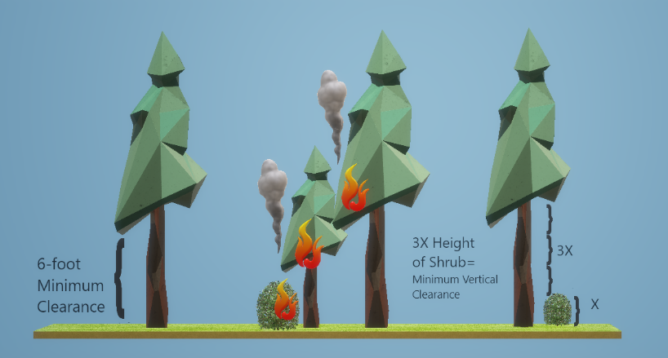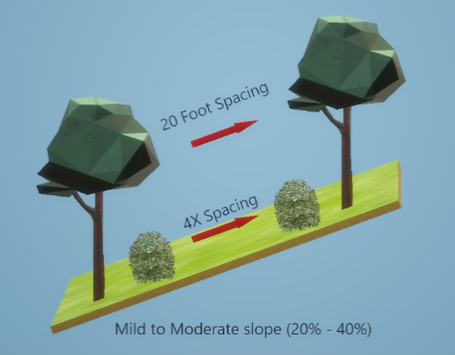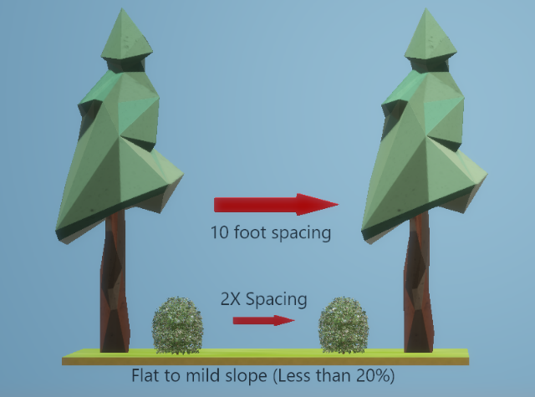

**READY FOR WILDFIRE**

It’s never been more important to keep on top of preparing your family home, and property for wildfire. Fires are on the rise and are burning hotter faster and more unpredictably than ever before. Create a custom wildfire preparedness plan and more.

Readyforwildfire.org Burnpermit.fire.ca.gov fire.ca.gov/dspace

Adequate defensible space acts as a barrier to slow or halt the progress of fire that would otherwise engulf your property. It also helps ensure the safety of firefighters defending your home. Defensible space is the first line of defense for your home against wildfire.

**VERTICAL SPACING**

Eliminate opportunities for a vertical “fire ladder” by:

* Remove branches beneath large trees for a 6-foot minimum clearance.
* Create proper vertical spacing between shrubs and the lowest branches of trees by using the formula shown.

**HORIZONTAL SPACING**

The spacing between grass, shrubs, and trees is determined by the type and size of the shrubs and trees, as well as the slope of the land. For example, a property on a steep slope with larger plant life will require greater spacing between trees and shrubs than a level property that has small, sparse vegetation.

**Fire-Safe Landscaping**

Fire-safe landscaping isn’t necessarily the same thing as a well-maintained yard. Fire-safe landscaping uses fire-resistant plants that are strategically planted to resist the spread of fire to your home.

**Dead Tree Removal**

If you have dead or dying trees on your property, the entire tree needs to be removed to reduce wildfire risk.

**ZONE 0 WITH HOME HARDENING**

Science has proven the 0 to 5-foot ember-resistant zone to be critical for protecting homes during wildfires. Eliminating flammable materials and vegetation is essential to prevent flying embers from igniting structures.

Defensible space and home hardening are necessary to increase the chances of surviving a wildfire. Take action now to prepare and protect your home before a fire occurs.

**Priority list for building or remodeling with ignition-resistant* materials:**

* Roof (most important)
* Eaves and Soffits
* Walls
* Decks
* Patio Cover
* Fencing

**Other priority activities:**

Vents: Cover and protect all openings.

Windows: Protect against blow-outs and install dual-paned windows.

Rain Gutters: Screen or enclose.

Chimney: Cover outlets with non-combustible screens.

Garage: Have an accessible fire extinguisher.

Driveways: Ensure access to your home complies with local fire codes.

Water Supply: Have multiple garden hoses that are long enough to reach all areas of your home.

*Visit ReadyforWildfire.org/hardening-your- home for detailed information on ignition-resistant building materials and all home hardening activities.